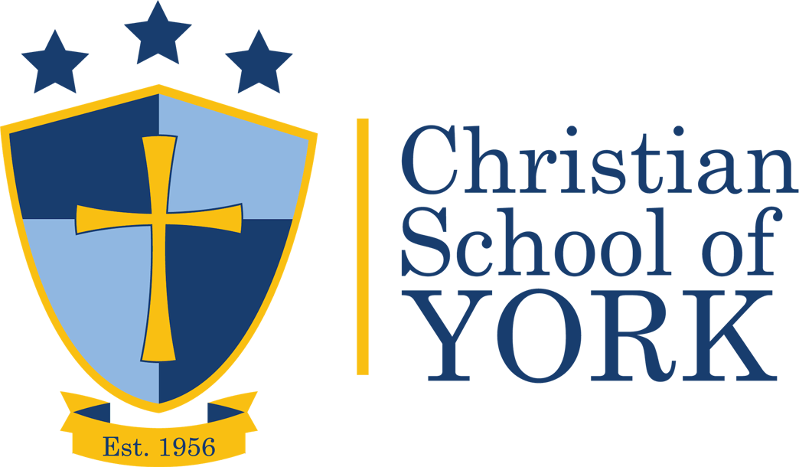
Basis of Faith
- We believe the Bible to be the inspired, the only infallible authoritative Word of God. (2 Peter 1:20,21; 2 Timothy 3:15,16)
- We believe that there is one God, eternally existent in three persons Father, Son and Holy Spirit. (Deuteronomy 6:4, Matthew 5:48, Matthew 28:19)
- We believe in the deity of our Lord Jesus Christ, in His virgin birth, in His sinless life, in His miracles, in His atoning death through His shed blood, in His bodily resurrection, in His ascension to the right hand of the Father, and in His personal return in power and glory. (Philippians 2:6-11, Luke 1:36-38, 1 Peter 3:18, Hebrews 2:9, Romans 5:9, Acts 2:23,24, Hebrews 8:1)
- We believe that for salvation of the lost and sinful man, regeneration by the Holy Spirit is absolutely essential. (Titus 3:4-7)
- We believe in the present ministry of the Holy Spirit, by whose indwelling the Christian is enabled to live a Godly life. (1 Thessalonians 5:23, Acts 1:8, Romans 6:1-14)
- We believe in the resurrection of both the saved and the lost; they that are saved unto the resurrection of life, and they that are lost unto the resurrection of damnation. (1 Corinthians 15:20-23, John 5:28, 29)
- We believe in the spiritual unity of believers in our Lord Jesus Christ. (Ephesians 1:22,23, Matthew 28:19-20, Acts 2:41-47)

