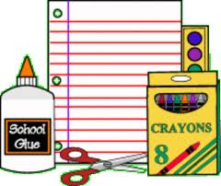
Supply list for Mrs. Jans PK 4

General Items – please label each item with child’s name
- Change of clothing for accidents – placed in a large Ziploc bag and labeled with child’s name (pants, shirt, underwear, socks)
- (1) 1.5 inch binder
- Backpack that will easily fit a binder
- Lunch Box (full day students only)
- Water Bottle
- (1) Plastic folder with bottom pockets
- KinderMat Kid’s Rest Mat (Red/Blue) (full day students only)
Must be this exact item for storage and hygiene purposes
Best price is to buy from Target – cost is $9.99
https://www.target.com/p/kindermat-kids-39-rest-mat-red-blue/-/A-17079315

Storage Items with Supplies – please label with child’s name
- Pencil Box with the following items:
- (1) Box of 8 Classic Colors Washable Markers
- (1) Pack colored dry erase markers
- (1) Pack of glue sticks
- (1) Bottle of Elmer’s white glue

- Clear Plastic Shoebox with the following items:
  - (3) Individual size – 4oz. containers of play-dough
  - (1) Paint Shirt (large t-shirt works best)

Classroom Items – no need to mark
- 2 containers disinfecting wipes (Clorox or Lysol or comparable - 35 wipes or more per container please)
- 3 rolls of paper towels
- 2 boxes of tissues
- 2 packs of baby wipes (unscented)

